COMPARATIVE ANALYSIS
CO4_AT3 — Assignment

Name: Madhu Balan I
Reg no: 192321142
Course: Computer Vision

1. Object Detection Performance Comparison
The supplied results are: Model A (Viola–Jones) has 80 true positives, 20 false positives, and 30 false negatives. Model B (YOLO) has 90 true positives, 15 false positives, and 20 false negatives.
Model | True Positives (TP) | False Positives (FP) | False Negatives (FN)
Model A (Viola–Jones) | 80 | 20 | 30
Model B (YOLO) | 90 | 15 | 20

Question: (a) Calculate the precision and recall for both models. (b) Compare the results and determine which model provides better overall object detection performance. Justify your answer based on the calculated values.
Answer:

Precision measures the proportion of predicted positive detections that are actually correct. The formula is Precision = TP ÷ (TP + FP). Recall measures the proportion of all actual positive objects that the model successfully detects. The formula is Recall = TP ÷ (TP + FN). A high precision means fewer false alarms, while a high recall means fewer missed objects.
For Model A, precision = 80 ÷ (80 + 20) = 80 ÷ 100 = 0.80, or 80.0%. Recall = 80 ÷ (80 + 30) = 80 ÷ 110 = 0.7273, or approximately 72.7%. Model A therefore identifies detected objects correctly 80% of the time, but it misses approximately 27.3% of the actual objects represented in the data.
For Model B, precision = 90 ÷ (90 + 15) = 90 ÷ 105 = 0.8571, or approximately 85.7%. Recall = 90 ÷ (90 + 20) = 90 ÷ 110 = 0.8182, or approximately 81.8%. Model B therefore produces fewer false alarms and misses fewer real objects than Model A.
The comparison is favourable to Model B on both measures. Its precision is approximately 5.7 percentage points higher than Model A’s precision, and its recall is approximately 9.1 percentage points higher. Model B also detects 10 more true positives, generates 5 fewer false positives, and produces 10 fewer false negatives. These improvements indicate better performance in both detection correctness and detection coverage.
An additional combined measure is the F1-score, calculated as F1 = 2 × (Precision × Recall) ÷ (Precision + Recall). Model A has an F1-score of approximately 76.2%, while Model B has an F1-score of approximately 83.7%. Because the F1-score balances precision and recall, this result confirms that Model B provides the stronger overall object-detection performance.
Model B (YOLO) should therefore be selected when the application values both reliable detections and broad coverage of objects. Model A may still be useful when computational simplicity is more important, but the supplied confusion-matrix results clearly show that Model B is the better-performing model. The final selection should also consider latency, hardware, and the relative cost of false positives and false negatives, but on the requested metrics Model B is superior.
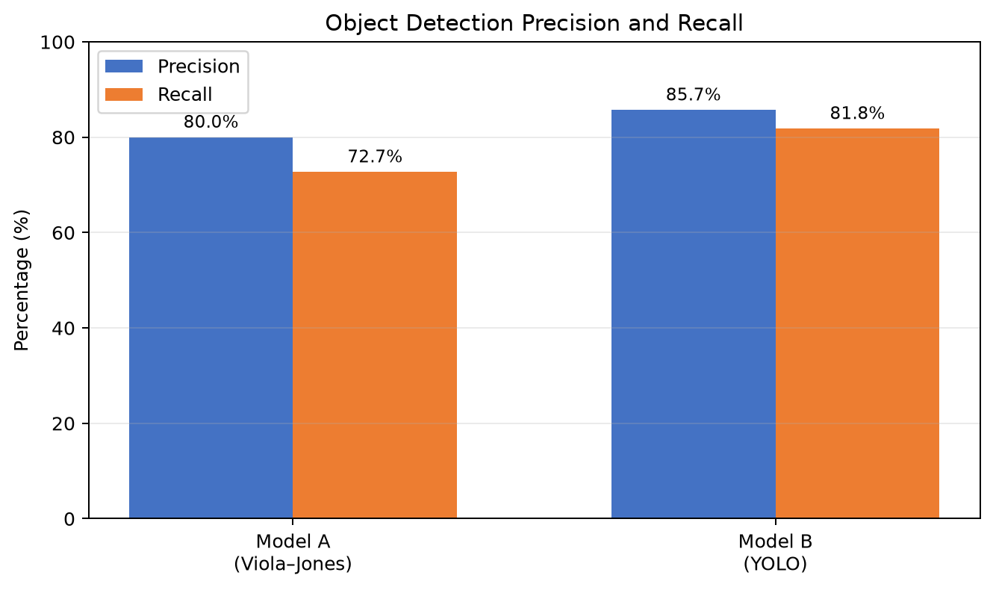
Figure 1. Precision and recall calculated from the supplied true-positive, false-positive, and false-negative values.

2. Motion Estimation Error Analysis

The displacement errors measured across three consecutive frames are Method A: 2, 3, and 2 pixels; Method B: 3, 5, and 4 pixels.
Frame | Method A error (pixels) | Method B error (pixels)
Frame 1 | 2 | 3
Frame 2 | 3 | 5
Frame 3 | 2 | 4

Question: (a) Calculate the average displacement error for both methods. (b) Compare the two methods and determine which method provides more accurate motion estimation. (c) Justify your answer based on the error values.
Answer:

The average displacement error is calculated by adding the errors for all frames and dividing by the number of frames. A lower average is better because it means the estimated motion is closer to the actual displacement on average.
For Method A, average error = (2 + 3 + 2) ÷ 3 = 7 ÷ 3 = approximately 2.33 pixels. For Method B, average error = (3 + 5 + 4) ÷ 3 = 12 ÷ 3 = 4.00 pixels.
Method A is more accurate because its average displacement error is approximately 2.33 pixels, compared with 4.00 pixels for Method B. The difference is about 1.67 pixels, meaning Method B’s average error is roughly 71% greater than Method A’s average error. Method A also has the lower error in every individual frame: 2 versus 3 pixels in Frame 1, 3 versus 5 pixels in Frame 2, and 2 versus 4 pixels in Frame 3.
The frame-by-frame values show that Method A is not only more accurate on average but also more stable. Its errors remain within the range of 2–3 pixels, whereas Method B varies from 3–5 pixels and reaches its highest error in Frame 2. This larger error may cause visible jitter, incorrect trajectory estimation, or inaccurate prediction of an object’s next position.
Based on the supplied measurements, Method A should be selected for accurate motion estimation. Method B could still be considered if it offers another important advantage, such as detecting fine motion that Method A misses, but that advantage is not represented in the data provided. For the specific objective of minimising displacement error, Method A is the clear choice.
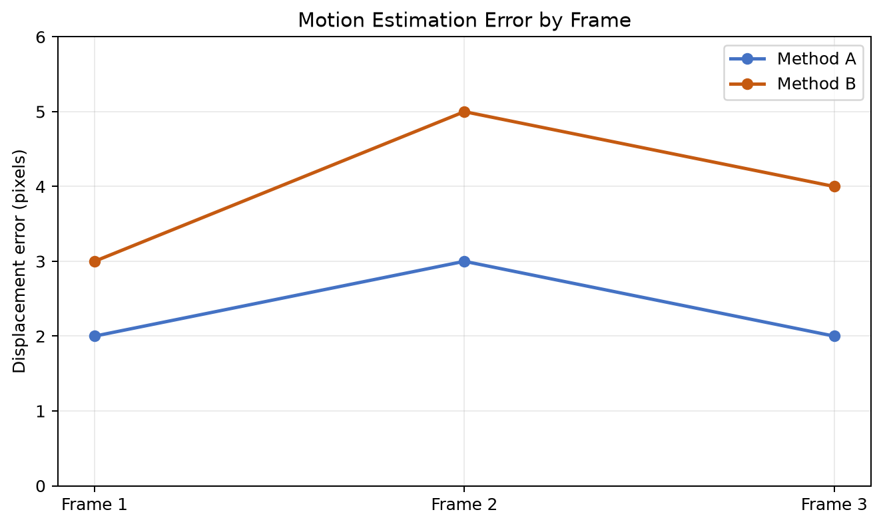
Figure 2. Frame-by-frame displacement errors. Method A has the lower error in all three frames and the lower average error.

3. Depth Estimation Comparison
The actual depths are 2.0 m, 3.0 m, and 4.0 m. Stereo Vision estimates 2.0 m, 3.0 m, and 4.0 m, while Structure-from-Motion (SfM) estimates 2.5 m, 3.8 m, and 5.0 m.
Object | Actual depth (m) | Stereo estimate (m) | Stereo absolute error (m) | SfM estimate (m) | SfM absolute error (m)
Object 1 | 2.0 | 2.0 | 0.0 | 2.5 | 0.5
Object 2 | 3.0 | 3.0 | 0.0 | 3.8 | 0.8
Object 3 | 4.0 | 4.0 | 0.0 | 5.0 | 1.0

Question: (a) Calculate the absolute error for each object for both methods. (b) Calculate the average absolute error for both methods. (c) Compare the methods and identify which provides more accurate depth estimation.
Answer:

Absolute error measures the size of the difference between an estimated depth and the actual depth, without considering whether the estimate is too high or too low. The formula is Absolute error = |Estimated depth − Actual depth|. This is appropriate here because the task asks how far each estimate is from the true distance.
For Stereo Vision, Object 1 has |2.0 − 2.0| = 0.0 m, Object 2 has |3.0 − 3.0| = 0.0 m, and Object 3 has |4.0 − 4.0| = 0.0 m. The total error is 0.0 m, so the average absolute error is (0.0 + 0.0 + 0.0) ÷ 3 = 0.0 m.
For SfM, Object 1 has |2.5 − 2.0| = 0.5 m, Object 2 has |3.8 − 3.0| = 0.8 m, and Object 3 has |5.0 − 4.0| = 1.0 m. The average absolute error is (0.5 + 0.8 + 1.0) ÷ 3 = 2.3 ÷ 3 = approximately 0.77 m.
Stereo Vision is more accurate on the supplied examples because its estimated depth matches the actual depth for all three objects. Its average absolute error is 0.0 m, compared with approximately 0.77 m for SfM. The SfM estimates are consistently higher than the actual values, so the method has a positive bias in this small sample: it overestimates the distance to every object.
The practical consequence of the SfM errors depends on the application. In an autonomous-vehicle or robotic system, overestimating depth could cause an object to appear farther away than it really is, which may affect collision risk calculations, path planning, or stopping decisions. Stereo Vision is therefore the better method for this dataset and objective.
However, the conclusion should be limited to the supplied measurements. Stereo Vision can be affected by poor texture, occlusion, weak lighting, and the need for good camera calibration, while SfM can be useful when camera motion and feature tracking provide enough information. A larger test set with different distances, lighting conditions, surface textures, and camera configurations would be required before making a universal claim. On the given data, nevertheless, Stereo Vision is decisively more accurate.
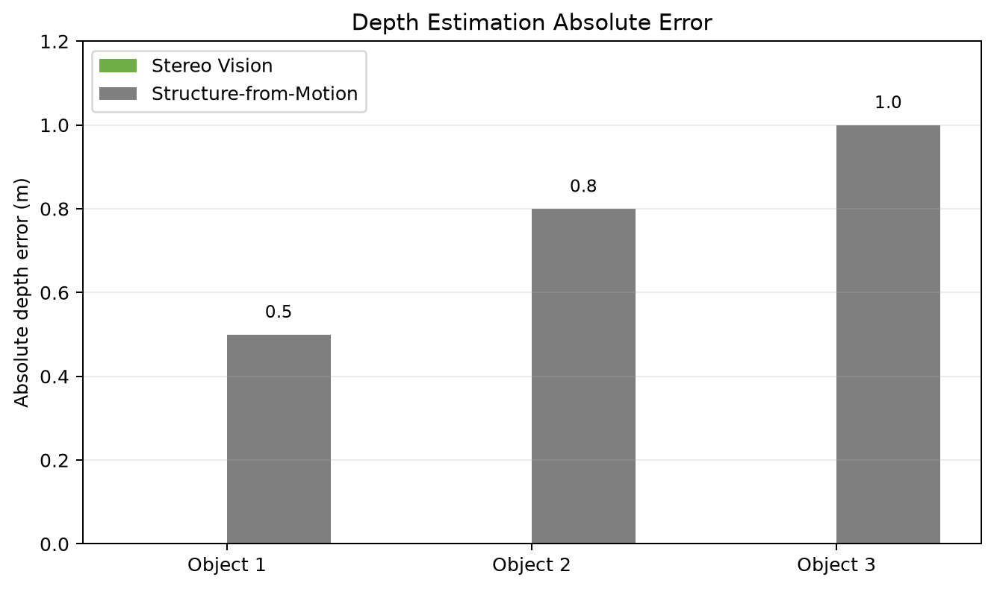
Figure 3. Absolute depth errors for each object. Stereo Vision has zero error for all three supplied objects, while SfM has increasing positive error.

